Control the various blinking frequency of led using (wireless technology) Arduino and Bluetooth Module (Hc05) via Android Device

1Bhargav Petla

1Bs-Ms, IISERB Bhopal

[bhargav18@iiserb.ac.in](mailto:bhargav18@iiserb.ac.in)

***Abstract*— The main aim of this project is to manifest and control the blinking of a LED using wireless technology(phone). Generally in the modern-day scenario, Bluetooth and wifi serve as the main platform for sending and the reception of data with the help of which we can send and transmit the data in different formats from one device to another device. The main goal of this project is to provide highly reliable communication between Arduino and Bluetooth such that any kind of android device can be connected with the board to send and transfer data from one end to the other end. The design of this project is done with the Arduino board and the uploading of the program is done with the help of Arduino software and the android phone acts as a transmitter. These are the main features of this report.**

***Index Terms*— Bluetooth, Arduino, Android, LCD**

I. INTRODUCTION

Today in the modern-day scenario we want reliable transmission of data and the reliable transmission of data can be provided with the help of wifi and Bluetooth module. Nowadays the wireless Communication becomes a spectrum by which we can send innumerable data streams from one channel to the other channel. The system involves the transmitter part and the receiver part which are used for transmitting and the reception of data. The Bluetooth module used here is HC05 which is a four-pin Bluetooth module which is used for the interfacing purpose with that of the Arduino board. This board is chosen because of its high demand and availability in the market. The Bluetooth which we are using here takes care of a short range of distance. i.e. within this short range, the data can be transmitted from the android to Arduino which makes led blinks with a designated frequency given in android. Arduino serves as the platform of hardware configuration and whereas the main media for transferring the data can is served with the Bluetooth module and apart from this, the coding for manipulation is done in the Arduino software environment which is a simple IDE environment used for uploading the sketches. Nowadays android phone has a quite efficient demand in the market due to its high superior manifestation in the market compared to the earlier operating systems which were expired now due to the modern-day motivation and the innovation in the technology department. With the help of the pairing between Arduino and the Bluetooth module, we are going to send the data whereas this part acts as a receiver one, and the android acts as a transmitter part to receive the data. Here in case of transmission and the reception of data the default baud rate is considered which is in the range of 9600.

II.OBJECTIVE

Control the blinking frequency of LED using Bluetooth receiver in Arduino and Transmitter as Android i.e. switches will be with one Transmitter and LEDs will be with Bluetooth module.

And Display the frequency of LED in an LCD

III. MATERIALS AND METHODS

*A. Hardware Part*

Arduino Uno Board

The Arduino Uno is an [open-source](https://en.wikipedia.org/wiki/Open-source) [microcontroller board](https://en.wikipedia.org/wiki/Microcontroller_board) based on the [Microchip](https://en.wikipedia.org/wiki/Microchip_Technology) [ATmega328P](https://en.wikipedia.org/wiki/ATmega328P) microcontroller and developed by [Arduino.cc](https://en.wikipedia.org/wiki/Arduino). The board is equipped with sets of digital and analog [input/output](https://en.wikipedia.org/wiki/Input/output) (I/O) pins that may be interfaced to various [expansion boards](https://en.wikipedia.org/wiki/Expansion_board) (shields) and other circuits.[[1]](https://en.wikipedia.org/wiki/Arduino_Uno#cite_note-Makerspace-1) The board has 14 digital I/O pins (six capable of [PWM](https://en.wikipedia.org/wiki/Pulse-width_modulation) output), 6 analog I/O pins, and is programmable with the [Arduino IDE](https://en.wikipedia.org/wiki/Arduino#Software) (Integrated Development Environment), via a type B [USB cable](https://en.wikipedia.org/wiki/USB_cable)

Breadboard:

The Breadboard is used as a connecting of the hardware samples with it with the help of connecting wires and the different interface mechanisms. In this project, the breadboard is used to connect the peripherals of the Arduino and the Bluetooth module.

Connecting wires:

The connecting wires are used to interface between the Arduino and alongside that of the Bluetooth module. The Arduino board is fixed on the breadboard and the receiver module of the Arduino is connected with that of the Bluetooth module to provide high ended reliable and efficient mode of communication. The connecting ends of the Arduino board are connected with that of the Bluetooth module and the connecting parts are explained as below:-

* TX OF Arduino is connected with RX of Bluetooth module
* RX of Arduino is connected with that of the TX of the Bluetooth module
* Vcc is connected to a 5V power supply
* Gnd of Arduino board is connected with the Gnd pin of Bluetooth module.

The above mentioned are the different connections that are used to interface between the Arduino board and the Bluetooth module.

LCD display:

In 16x2 LCD there are 16 pins overall if there is a back light, if there is no back light there will be 14 pins. One can power or leave the back light pins. Now in the 14 pins, there are 8 data pins (7-14 or D0-D7), 2 power supply pins (1&2 or VSS&VDD or GND&+5v), 3rd pin for contrast control (VEE-controls how thick the characters should be shown), and 3 control pins (RS&RW&E).

PIN1 or VSS to ground

PIN2 or VDD or VCC to +5v power

PIN3 or VEE to ground (gives maximum contrast best for a beginner)

PIN4 or RS (Register Selection) to PIN0 of ARDUINO UNO

PIN5 or RW (Read/Write) to ground (puts LCD in read mode eases the communication for user)

PIN6 or E (Enable) to PIN1 of ARDUINO UNO

PIN11 or D4 to PIN8 of ARDUINO UNO

PIN12 or D5 to PIN9 of ARDUINO UNO

PIN13 or D6 to PIN10 of ARDUINO UNO

PIN14 or D7 to PIN11 of ARDUINO UNO

Led:

The positive side of Led is connected to PIN13 in ARDUINO UNO and the negative side is connected to the ground.

*B. Software Part:*

Arduino software platform:

We upload the code using Arduino App on PC through a USB cable. The code is attached to the final report.

Android App:

Created android App using MIT App inventor consists of 4 buttons 3 buttons are frequency 1, frequency 2, frequency 3 and one-off button. When we press frequency 1 the led will start blinking with designated frequency 1 and the off button will turn led off from blinking

App and app file is uploaded here: <https://github.com/bhargavpetla/Bluetooth-module>

IV. DISCUSSION OF METHOD:

STEP 1:-arduino Uno fitted in the bread board.

STEP 2:-connecting HC05 Bluetooth module on the breadboard

STEP 3:-connecting the pins of arduino nano board with that of the Bluetooth pins and the connecting

With the help of these things the verification and compilation is achieved

STEP 4:-Downloading the arduino software from the arduino website.

STEP 5:-uploading the sketch in the arduino software

STEP 6: Before uploading the software the receiver parts are disconnected and the sketch is uploaded.

STEP 7:-on­­­­­­­­­­ce a successful compilation takes place the blinking of LED occurred.

STEP 8:-The blinking of LED can be controlled with the help of ANDROID.

STEP 9:-The android phone is the Transmitter part and with the help of these, we can get the information to the arduino board.

STEP 10:-Connect the lcd display to Arduino.]

STEP 11:- the blinking Frequency will be appear in LCD display.

How to use Android as transmitter:

Step-1 step-2 step-3

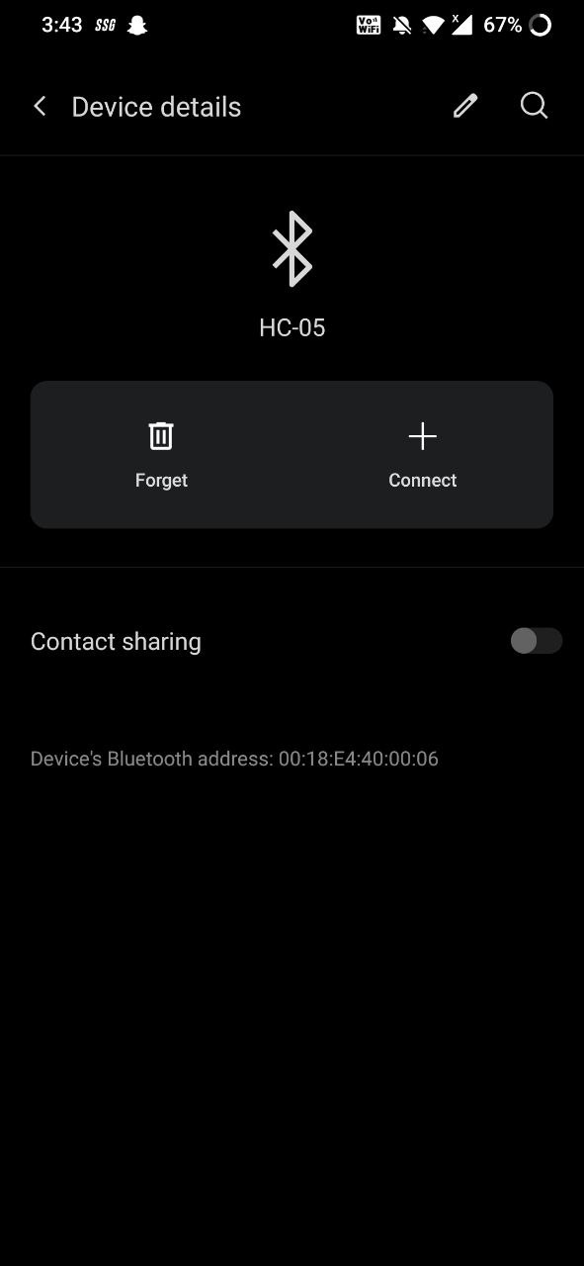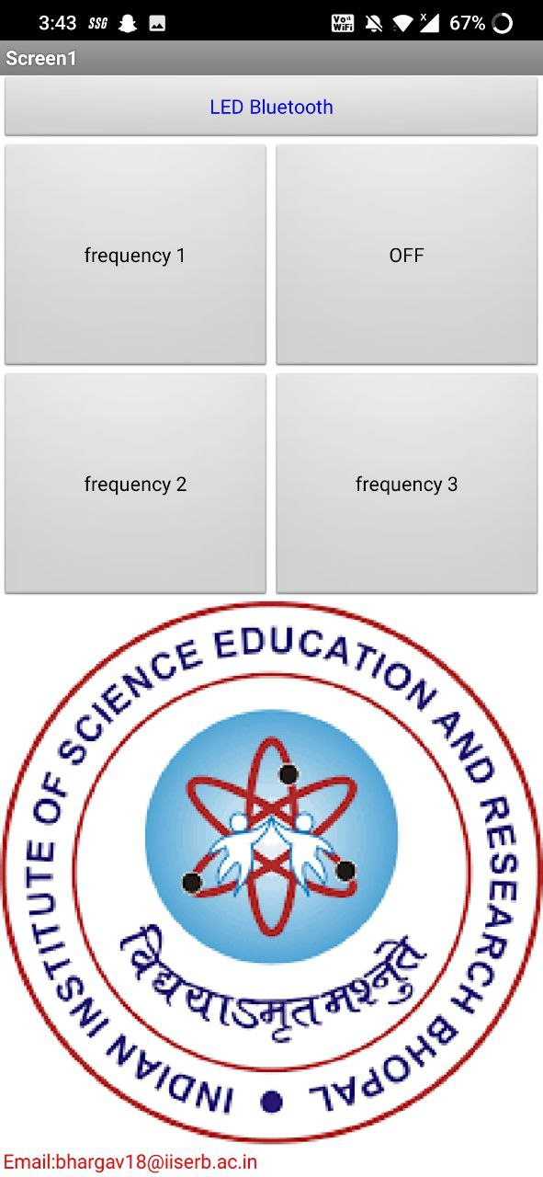 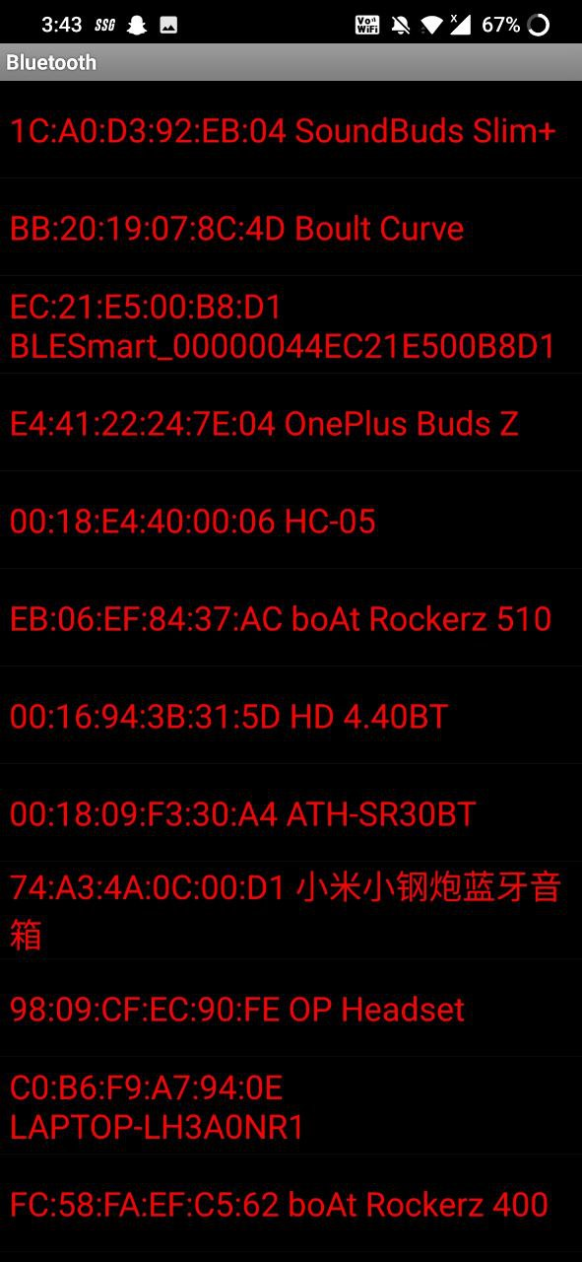

Then Press the frequency button for led to start blinking with the designated frequency

Frequency 1 is 0.5 Hz

Frequency 2 is 5Hz

Frequency 3 is 1Hz

V.CIRCUIT DIAGRAM:

1. Connection Bluetooth module:

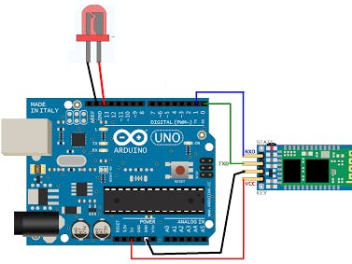

1. Connection Lcd Display:

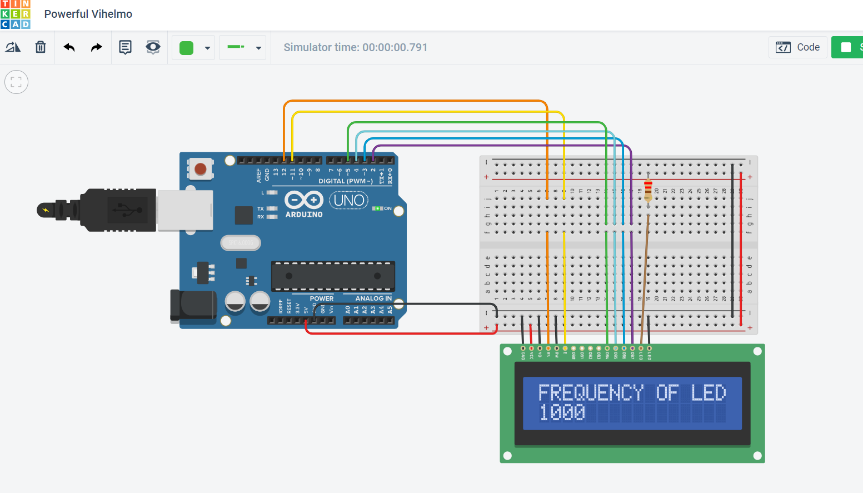

Image of the prototype

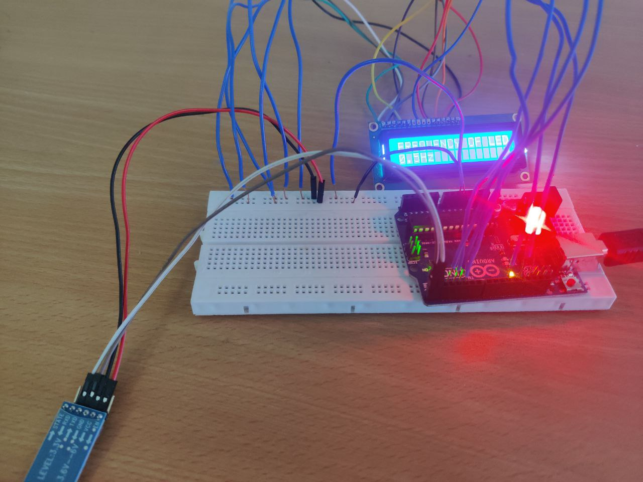

VI. RESULTS AND DISCUSSION:

HC 05 works in serial communication. The android app is designed to send serial data to the Arduino Bluetooth module when a button is pressed on the app. The Arduino Bluetooth module at the other end receives the data and sends it through the TX pin of the Bluetooth module (Connected to the RX pin of the Arduino). The code uploaded to the Arduino checks the received data and compares it.

If the received data is 1, the led blinks with 0.5HZ.

If the received data is 2, the led blinks with 5HZ.

If the received data is 3, the led blinks with 1HZ.

If the received data is 0, the led turns off.

VII. Conclusion:

The main view of this project illustrates the serial communication achieved between the Arduino board and the android mobile device. With the help of this communication the buildup is done between the device and finally, we can establish serial communication between the two devices. Once the setup is being established and the pairing is done with the mobile phone and with the help of this we can obtain the data send from the android and also the configuration of LED can also be controlled with the help of android.

VII. References:

[1] https://www.arduino.cc/

[2] https://appinventor.mit.edu/

[3] https://maker.pro/

[4] https://howtomechatronics.com/